[MyEducator Home Page](https://www.myeducator.com/)

* [BMIS 441 02: Database Manag...](https://app.myeducator.com/course/activity/617eba/2701101298226397185/#)
* [Contents](https://app.myeducator.com/course/activity/617eba/2701101298226397185/#)
* Course
* Nathan Yoon

# **BMIS 441 02: Database Management [Fall 2021]**

## **SQL Assignment #7-Convert Simple Diagrams**

For this assignment, your grade will be granted in such way:

100-very good , 90-good, 80-somewhat good, 70-not good.

Create a relational schema for each of the following diagrams using the textual notation:

Table names are shown at the beginning and attributes are listed in parentheses. Primary keys are underlined. Foreign keys are indicated by using a dashed line or using a note to indicate "reference".

Here is an example:

**Department** (DepartmentID, DepartmentName, ManagerID)

ManagerID references Employee

**Employee** (EmployeeID, FirstName, LastName, HireDate, DepartmentID)

DepartmentID references Department

**PerformanceReview** (ReviewID, ReviewDate, ReviewScore, Notes, EmployeeID, ManagerID)

EmployeeID references Employee

ManagerID references Employee

| Due Date: | Oct 17 at 23:59 |
| --- | --- |
| Points: | 100 |

Graded on Oct 21 at 12:20

Your Submission:

| Submission Score: | 100 / 100 (100.00%) |
| --- | --- |
| Grade Time: | Oct 21 at 12:20 |
| Submitted On: | Oct 17 at 16:53 |

1. 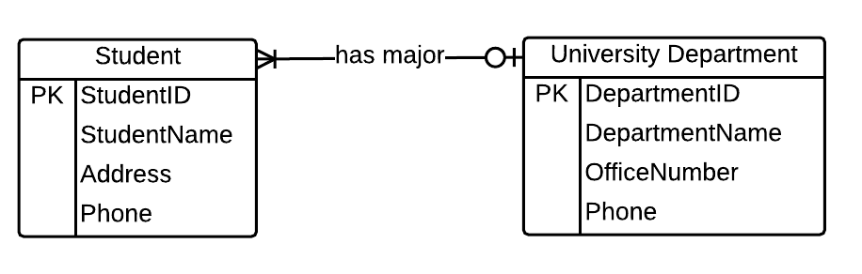  
   ***Student (StudentID, StudentName, Address, Phone, DepartmentID)   
   DepartmentID references University Department   
   University Department (DepartmentID, DepartmentName, OfficeNumber, Phone)*FEEDBACK**Ungraded / 15
2. 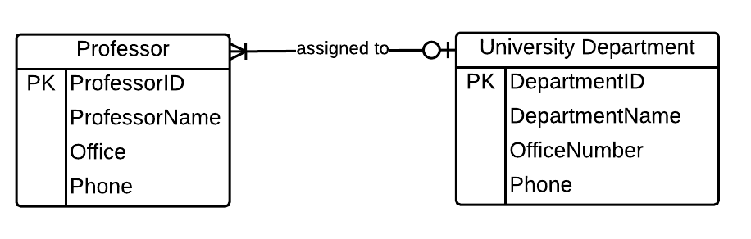  
   ***Professor (ProfessorID, ProfessorName, Offie, Phone, DepartmentID)   
   DepartmentID references University Department   
   University Department (DepartmentID, DepartmentName, OfficeNumber, Phone)*FEEDBACK**Ungraded / 15
3. 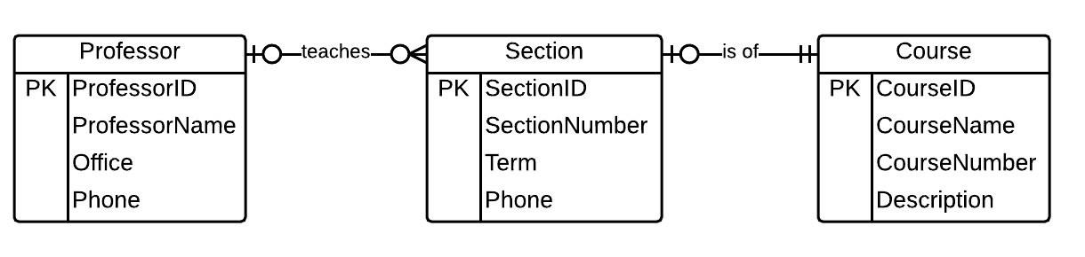  
   ***Professor (ProfessorID, ProfessorName, Office, Phone)   
   Section (SectionID, SectionNumber, Term, Phone, ProfessorID, CourseID,)   
   CourseID references Course  
   ProfessorID references Professor  
   Course (CourseID, CourseName, CourseNumber, Description)*FEEDBACK**Ungraded / 15
4. 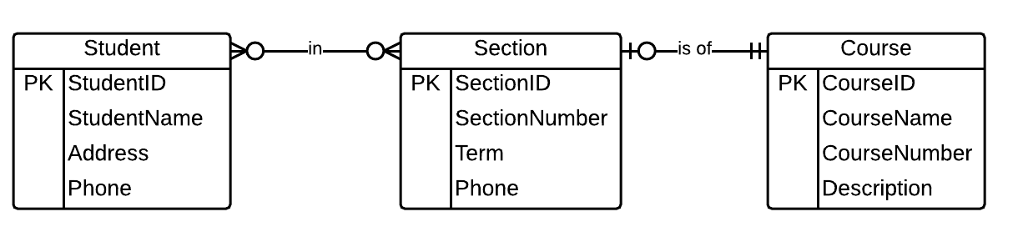  
   ***Student (StudentID, StudentName, Address, Phone)  
   Section (SectionID, SectionNumber, Term, Phone, CourseID)  
   CourseID references Course  
   Course (CourseID, CourseName, CourseNumber, Description)  
   StudentInSection (StudentID, SectionID)  
   StudentID references Student   
   SectionID references Section*FEEDBACK**Ungraded / 15
5. 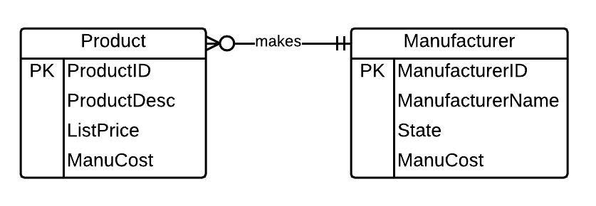  
   ***Product (ProductID, ManufacturerID, ProductDesc, ListPrice, ManuCost, ManufacturerID)   
   ManufacturerID references Manufacturer  
   Manufacturer (ManufacturerID, ManufacturerName, State, ManuCost)*FEEDBACK**Ungraded / 15
6. 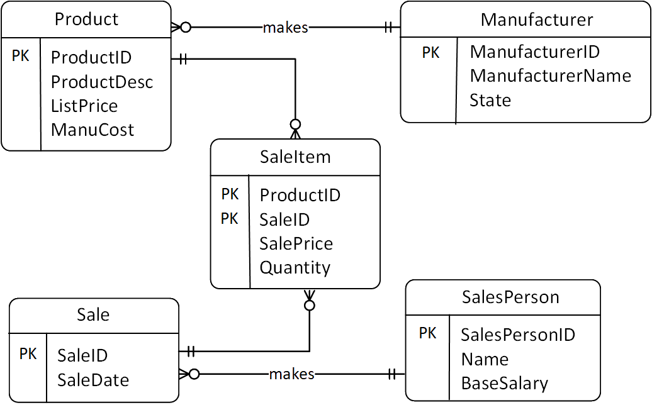  
   ***Manufacturer (ManufacturerID, ManufacturerName, State)  
   Product (ProductID, ProductDesc, ListPrice, ManuCost, ManufacturerID)  
   ManufacturerID references Manufacturer  
   SaleItem (ProductID, SaleID, SalePrice, Quantity)  
   ProductID references Product  
   SaleID references Sale  
   Sale (SaleID, SaleDate, SalesPersonID)  
   SalesPersonID references SalesPerson  
   SalesPerson (SalesPersonID, Name, BaseSalary)*FEEDBACK**Ungraded / 25

Copyright © 2022 MyEducator. All rights reserved.

[Need Help?](https://myeducator.freshdesk.com/support/home)